**Experiment No.: 1 DATE : 19/12/2022**

**Aim**

**Program to read file content and store it into a list using readlines().**

**CO5**

**Procedure**

# Program to read file content and store it into a list using readlines().

open_file=open('file_01.txt','r')

File_Lines=open_file.readlines()

# Without using strip method

print("\nFile content with newline character : ")

print(File_Lines)

# Using strip method

print("\nFile content after removing newline character : ")

#File_Lines=[X.strip() for X in File_Lines]

#print(File_Lines)

print([X.strip() for X in File_Lines])

#==>using list comprehension,we can avoid the above steps

open_file.close()

**Output Screenshot**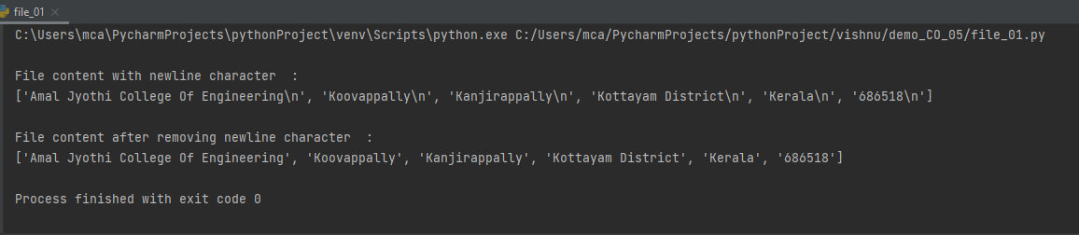

**Result**

The program was executed and the result was successfully obtained. Thus CO1 was obtained.